2
Ethernet Controller_______
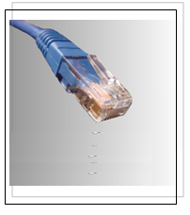 Chapter 5: Industrial Control Busses
Chapter 6: Ethernet Interface Hardware
Chapter 7: Ethernet Interface Software
This part includes the hardware and software needed for the implementation of the Ethernet interface between the Software side in the Laptop or PDA, as well as the control loops of the real processes.
After short notes on theoretical background of Reference Models and Protocol Stacks as well as the TCP Protocol used in our project.

